|  |  |  |
| --- | --- | --- |
|  |  | |
|  | D3.1 – Scenario and Metrics Definition Report | |
|  | Deliverable ID: | D3.1 |
|  | Dissemination Level: | PU |
|  | Project Acronym: | Metropolis 2 |
|  | Grant: | 892928 |
|  | Call: | H2020-SESAR-2019-2 |
|  | Topic: | SESAR-ER4-31-2019 U-space |
|  | Consortium Coordinator: | TUD |
|  | Edition Date: | 19 January 2022 |
|  | Edition: | 02.00.01 |
|  | Template Edition: |  |

|  |
| --- |
| EXPLORATORY RESEARCH |



|  |  |  |
| --- | --- | --- |
| Authoring & Approval | | |
| Authors of the document | | |
| Name/Beneficiary | Position/Title | Date |
| Andrija Vidosavljevic - ENAC | WP3 leader T3.2 leader Project support | 26 April 2021 1 September 2021  21 November 2021  30 November 2021 |
| Andrei Badea - TUD  Andres Morfin Veytia | T3.1 leader Project support | 1 September 2021  21 November 2021 |
| Niki Patrinopoulou – UoP  Ioannis Daramouskas | Project support | 21 November 2021 |

|  |  |  |
| --- | --- | --- |
| Reviewers internal to the project | | |
| Name/Beneficiary | Position/Title | Date |
| Joost Ellerbroek | Project leader | 25 November 2021 |

|  |  |  |
| --- | --- | --- |
| Approved for submission to the SJU By - Representatives of beneficiaries involved in the project | | |
| Name/Beneficiary | Position/Title | Date |
|  |  |  |
|  |  |  |

|  |  |  |
| --- | --- | --- |
| Rejected By - Representatives of beneficiaries involved in the project | | |
| Name/Beneficiary | Position/Title | Date |
|  |  |  |
|  |  |  |

|  |  |  |  |  |
| --- | --- | --- | --- | --- |
| Document History | | | | |
| Edition | Date | Status | Author | Justification |
| V0.1 | 26/04/2021 | Draft | Andrija Vidosavljevic | Document template |
| V0.2 | 01/09/2021 | Draft | Andrija Vidosavljevic  Andrei Badea  Andres Morfin Veytia | Chapter 1 and 2 structure |
| V1.0 | 21/11/2021 | Final draft | Andrija Vidosavljevic  Andrei Badea  Andres Morfin Veytia Niki Patrinopoulou  Ioannis Daramouskas | City choice and modelling Traffic demand modelling Scenario definition Metric definition |
| V1.1 | 25/11/2021 | Final draft reviewed |  | Document review/approval |
| V2.0 | 30/11/2021 | Final | Andrija Vidosavljevic | Consolidation of Final approved document |
| V2.0.01 | 19/01/2022 | Final | Joost Ellerbroek | Fixed document name on title page, revision date in this table. |

Copyright Statement

*© – 2021 –METROPOLIS 2 Consortium. All rights reserved. Licensed to the SESAR Joint*

*Undertaking under conditions.*

*[Copyright owner statement – please refer to*

*<https://stellar.sesarju.eu/> > Programme FAQ 088 > Copyright disclaimer in Document]*

Metropolis 2

a unified approach to airspace design and separation management for u-space

This Project Management Plan is part of a project that has received funding from the SESAR Joint Undertaking under grant agreement No 892928 under European Union’s Horizon 2020 research and innovation programme.

EU logo low res

Abstract

Metropolis 2 will provide the fundamentals for concrete solutions for U-space U3/U4 services that are needed to enable high-density urban aerial operations, with a unified approach to the following U-space services: strategic deconfliction, tactical deconfliction, and dynamic capacity management. Thus far, U-space efforts have focused on developing a set of baseline services (i.e., U1 and U2 capabilities enabling services such as identification, flight planning, and tracking). When deployed, these services will enable low traffic density applications such as agricultural surveillance and infrastructure inspection. Urban, high-density operations, however, will require a different approach, and a degree of autonomy that does not yet exist in current-day air traffic management. First, in order to sustain high traffic demands, the urban airspace must be able to allow a shared use of airspace, rather than the approach used today of exclusively assigning parts of the airspace to individual flights. Secondly, at the expected extremely high traffic densities, airspace design, flight planning, and separation management become increasingly interdependent. With the traffic densities that are considered for urban applications these interdependencies necessitate a unified approach to all aspects of traffic management that determine how vehicles interact with each other. This project will develop a unified approach to airspace rules on the one hand, and flight planning and separation management approaches on the other hand. It will build upon the results of the current U-space projects, the first Metropolis project, and established separation algorithms. Several concepts, differing in how separation is performed (strategic/tactical, ground/air) will be compared using simulations, and the most promising concept will be validated in a real-world demonstration. The results of Metropolis 2 will contribute towards enabling safe and efficient U-space operations in urban environments.

Table of content

Abstract 4

1 Introduction 7

2 Scenario definition 9

2.1 Simulated environment 9

2.2 Mission design 13

2.3 Uncertainties 15

2.4 Baseline scenarios 17

2.5 Scenario overview 17

3 Metric definition 19

3.1 Access and equity 20

3.2 Capacity 24

3.3 Efficiency 26

3.4 Environment 30

3.5 Safety 35

3.6 Priority 36

3.7 Summary of all proposed indicators 38

4 References 42

List of Tables

Table 1. Average and Maximum instantaneous traffic densities for different traffic scenarios 15

Table 2. Traffic mix proportions. 17

Table 3. Summary of the indicator proposed in the Metropolis 2 38

List of Figures

Figure 1. Metropolis 2 concepts 7

Figure 2. WP3 position and interrelation with other work packages 8

Figure 3: OSMnx graph 10

Figure 4: Simplified Street Graph 11

Figure 5. Experimental simulation environment 13

Figure 6. Constant wind vector within each simulation scenario, different between scenarios 16

Figure 7. Wind vector projected on direction of travel 16

Figure 8. Metropolis 2 experiment matrix. 18

Figure 9. Actual and ideal horizontal path. The origin point is coloured green, the destination point is red. The actual route is shown blue, while the ideal route is the yellow arrow. 27

Figure 10. Graph of the altitude for the ideal vertical route (in black) and the actual vertical route (in blue). 28

Figure 11. Graph of the ascends for the ideal vertical route (in black) and the actual vertical route (in blue). 29

Figure 12. Environmental concerns in the UTM (Delahaye, et al., 2014) 31

Figure 13. Vertical profile example 32

Figure 14. Sound intensity reduction with distance 33

Figure 15. A conflict is a predicted loss of separation within the look-ahead time. 35

Figure 16. An intrusion occurs when the distance between two aircraft is smaller than the separation margin (protection zone radius Rpz). 36

# Introduction

The Metropolis 2 project seeks concrete solutions for UTM that are needed to enable high-density urban aerial operations, with a unified approach to the following U-space services: strategic deconfliction, tactical deconfliction, and dynamic capacity management.

Several concepts (Figure 1), differing in how separation is performed (strategic/tactical, ground/air) will be proposed and compared using simulations, and the most promising concept will be validated in a real-world demonstration trial. The results of Metropolis 2 will contribute towards enabling safe and efficient U-space operations in urban environments.

Figure 1. Metropolis 2 concepts

The main project research questions are as follows. What is the effect of the deployed separation and flight management strategy on the urban airspace performance: centralised, hybrid and decentralised? What is the effect of each individual component of the deployed separation and flight management strategy: strategic and tactical?

To answer these questions, the ultimate objective of WP3 is to perform comparison and trade-off analyses of the different U-space design concepts, and to select the most promising of these concepts for the validation phase. To achieve this, the work in WP3 is organized in 4 tasks, as shown in Figure 2:

* Task 3.1 – Scenario definition
* Task 3.2 – Metrics definition
* Task 3.3 – Results analysis
* Task 3.4 – Trade-off

Before concept simulation and performance analysis it is necessary to:

* Develop scenarios that will be used in the simulation trials to test the concepts, and
* Define metrics that would be used to compare the quality of the concepts.

The results of these two tasks are reported in this D3.1 report.

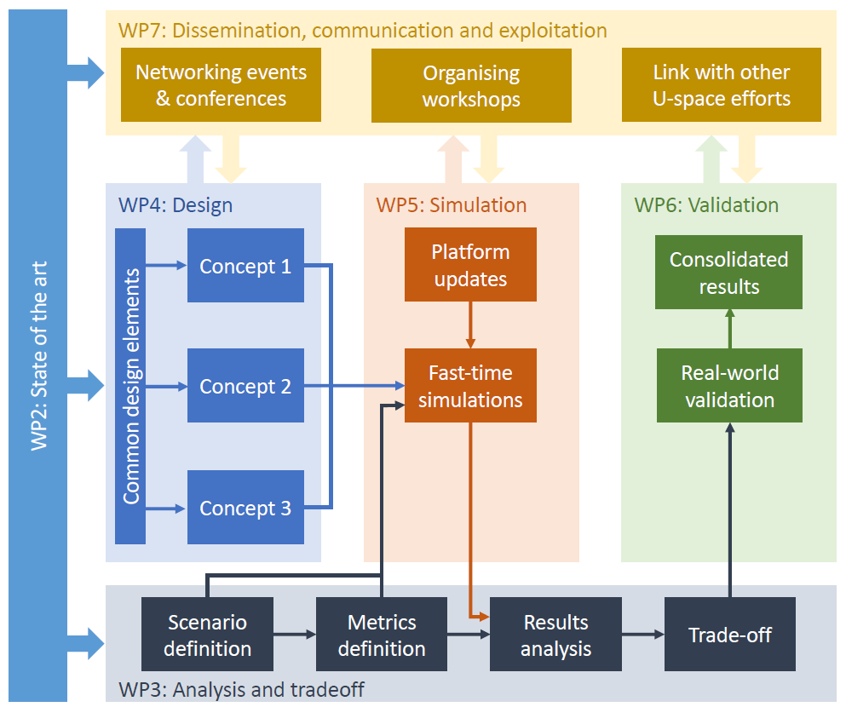

Figure 2. WP3 position and interrelation with other work packages

This document is intended to be used by SJU programme manager and by Metropolis 2 members.

Metropolis 2 WP4 members, responsible for the concept developments are first concerned since concept common elements, that should be respected by all concepts, are defined here.

WP3 T3.3 and T3.4 members are also direct users of the document since the platform for the result analysis, that should be developed as part of task 3.3, as well as results and trade-off analysis are performed based on the metrics defined in this report.

This report defines the scenarios that will be used in the simulation trials, and furthermore, provides the requirements on the simulation environment, with respect to inputs that are needed for the metric computations, hence adding at the list of intended readerships the WP5 members.

Finally, international research community members interested in the UTM system simulation and latest developments of metrics suitable for the evaluation of UTM system performance.

# Scenario definition

To test the operational concepts developed within the Metropolis 2 project, simulations will be performed using the BlueSky Open Air Traffic Simulator. For this, an urban simulation environment was created and populated with traffic spanning a wide range of missions. The following chapter presents the steps and motivation for creating these traffic scenarios.

## Simulated environment

### City choice

As the Metropolis 2 project concerns urban aerial operations, the simulation environment needs to reflect a city layout. The Metropolis 2 team decided to select the infrastructure of an existing city as a starting point. Most previous research has focused on above-buildings air operations (Barrado, et al., 2020), or between-buildings in a highly orthogonal street network (Doole M. , Ellerbroek, Knoop, & Hoekstra, 2021). The Metropolis 2 project aims to cover a wide variety of situations and operational modes. Thus, both situations in which aircraft follow the street network (and thus fly between buildings and avoid them) and fly freely (no obstacles in the form of buildings) will be considered.

The city of Vienna was chosen as the basis of the simulated urban environment due to several reasons. The first is that there is a lot of up-to-date open-access data put forward by the Vienna municipality, including demographics and infrastructure data, which is useful in generating realistic traffic scenarios. The second reason is that Vienna has both organic and orthogonal street network features, which increases the diversity of traffic situations. Finally, the street network of Vienna has a high network connectivity index (Boeing G. , 2019), which facilitates the simulation of traffic within its bounds.

### Airspace structure

First, an experiment area was defined as a circular area with a radius of 8 kilometres around the geographical centre of Vienna. This circle includes most of the highly populated areas of the city, as well as sparsely populated areas on the outskirts. All simulated missions have their origin and their destinations within this area, and no traffic leaves or enters the airspace from outside. Vertically, the airspace has a maximum allowable cruise altitude of 500ft, following the current definition of Very Low Level (VLL) airspace.

The airspace was then divided into two areas: constrained airspace, where aircraft must follow the drivable street network of the city, and open airspace, where aircraft can fly assuming there are no obstacles other than restricted airspace areas. The division was made based on population density and building type. Areas with large building footprints were included, while suburban areas with individual houses were placed in open airspace. The restricted (geofenced) airspace areas are based on locations of landmarks such as parks and cemeteries. They span from the lowest altitude to approximately 300±50 ft.

Finally, the street network data was obtained from the OpenStreetMap database. Due to the way this data is modelled, the street graph was simplified by eliminating redundant graph edges (wide street modelled as several streets) and dead-ends.

### Street-data processing

Street network data is required for planning and execution of flights between buildings in constrained airspace. The Open Street Map (OSM) project freely provides street data all over the world. However, since it is a community project, the accuracy and detail vary from place to place. Thus, it is important to use OSM data where it can be shown that the geometry is accurate. Barrington-Leigh and Milliard-Ball analysed completeness in OSM all over the world and stated that the street data of Europe is 95 % complete (Barrington-Leigh & Millard-Ball, 2017). Moreover, OSM placed Vienna in their 100% complete list (OpenStreetMap, 2009).

OSM networkx (OSMnx) is a python library that converts OSM street data into a graph (Boeing G. , 2017 ). A graph is a representation of a street network where intersections and streets are represented as nodes and edges, respectively (Figure 3). The process for extracting an OSMnx graph in a custom area is as follows:

1. Select a polygon that defines the area in which OSMnx will query data from OSM. The figure below shows the polygon in a light blue shade.
2. Call the **graph_from_polygon()** OSMnx function with optional argument **network_type=’drive’**.

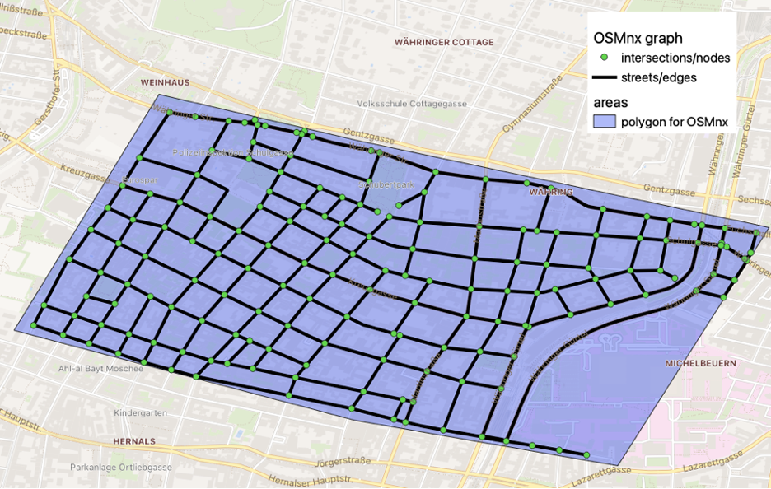

Figure 3: OSMnx graph

The street network is furthered simplified for ease-of-use as follows:

* Removal of unconnected streets. This removes all edges that have a node with degree-1 at any end.
* Convert two-way streets to one-way. The graph may contain some two-way streets because OSMnx maintains the directionality defined by OSM. In the Metropolis 2, it is assumed that the width of the streets allows to only accommodate one flow per street at the time (without assuming, neither limiting its direction), so all two-way edges are converted to one-way.
* Remove long-way edges. The OSMnx graph is by default a multi-directed graph. This means that there can be several edges connecting the same two-nodes. In these cases, the edges with a longer distance are removed.
* Roundabouts are simplified into simpler intersections.
* Parallel edges closer than the minimum separation distance are combined when possible. An example of a simplified graph of a small test section is seen below.

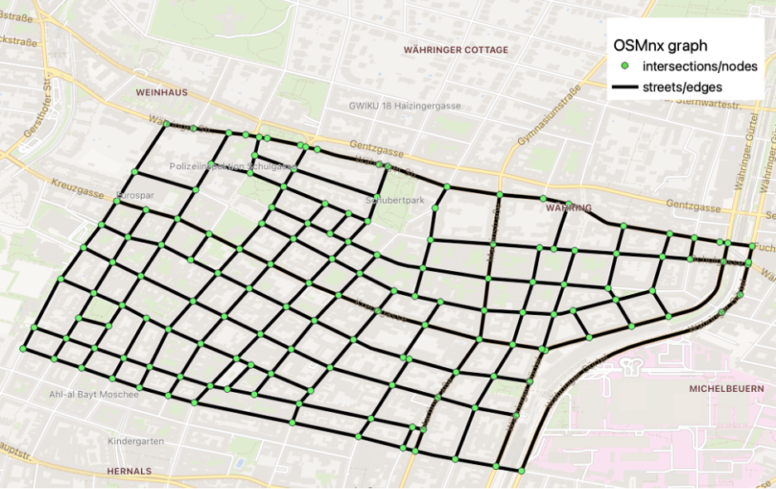

Figure 4: Simplified Street Graph

### Building data-processing

Building information is necessary to calculate geofence intrusions. In the Metropolis, drones may not fly between the buildings out of the street network, hence, individual buildings in the same city block surrounded by the streets are grouped together. The building data was obtained from the government of Vienna (City of Vienna, 2021). Simple processing was performed to combine adjacent polygons i.e, buildings into polygons representing city block. Furthermore, all polygons are assumed to extend the height of the airspace, due to the assumption that in the constrained airspace all vehicles must follow street network, hence, no overfly of the buildings.

### Vertiport locations

Conceptually, vertiports are places that can receive and send out flights. They resemble mailboxes for the neighbouring population and are distributed all over the city. The vertiports are placed uniformly per municipality (see yellow circles in Figure 5). The number of vertiports in each municipality is determined based on the municipal demand (see section 2.2.4) and two hypothesis on vertiport throughput and maximum walking distance, as follows:

1. Each vertiport can handle 20 landings per hour. This value assumes that an average landing is expected to take about 2 minutes. On top of that there is a minute leeway to allow for other tasks, like loading/removing cargo or batteries.
2. Each vertiport covers at most half a square kilometre. This constraint is made such that in less dense areas, there is still always a vertiport in walkable distance from any point.

It is assumed that within a municipality there is on average no difference between the vertiports in terms of demand. Furthermore, each vertiport is split into sending and receiving nodes that is separated by at least the minimum separation distance. This was done so to separate arrival and departure flows, that an arriving aircraft will have a lower chance of conflicting with a departing aircraft.

### Distribution centres

Distribution centres are like warehouses in the sense that most of the traffic will originate from them. This is also what is seen today in normal delivery services, where the mail delivery drivers can return to a central location several times during their shift to pick up new cargo. Hence, the distribution centres were placed near existing mail pickup points located in Vienna (see blue circles in Figure 5).

It is assumed that majority of the shipments would be delivered over the one of the closest distribution centres (that is also the case today). Hence, the distribution centre capacity i.e., the number of scheduled package deliveries from a given distribution centre, is determined based on total demand, and surrounding population wealth and size, that determine distribution of total demand per municipality. As a result, distribution centre capacity differs. Furthermore, due to available place, it is assumed that a distribution centres size won’t be equal over the city, being smaller in core city centre and larger in the suburbs. Hence, in the city centre, where the demand is bigger, the centres would be greater in number (see Figure 5).

To allow simultaneous operation at the distribution centre, every distribution centre have multiple vertiports, that are positioned around actual vertiport location and separated by at least the minimum separation distance. The number of vertiports per distribution centre is determined based on distribution centre capacity and vertiport throughput, as explained in 2.1.5. The distribution centre vertiports are not shown in Figure 5.

Figure 5. Experimental simulation environment

## Mission design

### Common flight rules

A set of common flight rules was established for all concepts, and are as follows:

* Planned routes may not leave the experiment area.
* In open airspace, there are no heading restrictions.
* In constrained airspace, traffic must follow the street network.
* Any given street can laterally only accommodate one vehicle at a time i.e., vehicles follow a street centre line.
* The minimum separation limits are 32 metres horizontally and 25 feet vertically, based on the ICAO Annex 10 GNSS system specifications.
* The lookahead time for tactical separation management is 10 seconds.

### Mission types

In the Metropolis 2 project, there will be four mission types considered for simulation, as follows:

#### Parcel deliveries

Parcel deliveries are missions that depart from distribution centres towards various destinations within their range. These will produce an outflow pattern from the locations of the distribution centres to other parts of the city.

#### Food deliveries

These missions are characterised by their variety in origins and destinations. As restaurants or catering locations can be anywhere in the city, these missions can also be conducted from any vertiport to any other vertiport in the city.

#### Loitering missions

Loitering missions are missions that reserve airspace for their operations (e.g., surveying). These missions travel to a certain area of the city and enact a geofence.

#### Emergency missions

They are point to point missions as food delivery, but information about these missions appears shortly before departure.

### Mission priority

The missions simulated within the Metropolis 2 project will be assigned three levels of priority: low, medium, and high. These will be assigned in equal proportions to the missions. Within strategic and tactical conflict prevention and resolution, traffic should be prioritised in function of priority level. Emergency vehicles are considered separately and have priority over all priority levels i.e., ultra hight priority level.

### Traffic density

Five traffic densities will be studied: very low, low, medium, high, and very high. These densities are based on the nominal yearly demand of Vienna which was estimated based on the regression and interpolation analysis of parcel markets in other parts of Europe. The features used in regression are: city area and population size, average annual gross salary. The parcel market data are taken from Pitney Bowes’s annual parcel shipping report (Pitney Bowes, 2020) which covers the more western countries of Europe. Furthermore, framework proposed in (Doole, Ellerbroek, & Hoekstra, 2020) is used to filter out the potential drone-based parcel market scenarios with different density levels. Yearly demand is reduced to daily as simple average without taking seasonality into account.

The total demand was then distributed amongst the 23 municipalities of Vienna using linear regresion. Following features i.e., predictors with different weights were used to calculate the demand per hour of the different municipalities: surface area, population density (as measured in 2020), employee per workplace (as measured in 2018), total number of people employed in workplace (as measured in 2018), commuter balance index (as measured in 2018), and annual gross salary (as measured in 2019) (City of Vienna, 2019) (Statistik Austria, n.d.). Table 1 shows the average and maximum expected instantaneous traffic density based on estimated traffic demand levels.

Table 1. Average and Maximum instantaneous traffic densities for different traffic scenarios

|  |  |  |
| --- | --- | --- |
| **Traffic scenarios** | Average instantaneous traffic density (aircraft per square kilometre) | Maximum instantaneous traffic density (aircraft per square kilometre) |
| Very Low | 14,68 | 54,75 |
| Low | 20,45 | 76,26 |
| Medium | 26,21 | 97,77 |
| High | 31,98 | 119,28 |
| Very High | 37,75 | 140,79 |

### Aircraft types

To increase heterogeneity of the traffic scenarios and hance its realism, there will be two aircraft types simulated, mainly differentiated by their maximum (cruise) speed: 20, and 30 kts. Both types of aircraft have the ability to hover, as it facilitates the navigation of constrained airspace. The two aircraft will be represented in equal proportion throughout the scenarios.

## Uncertainties

The inclusion of uncertainties is required: firstly, for the realism of the simulation, and secondly, to test the robustness of strategies for the separation management. The following section presents the uncertainties used within the Metropolis 2 simulation traffic scenarios.

### Wind

Within the Metropolis 2 project, wind is modelled as uncertainty in aircraft velocity in order to test the robustness of the used strategic and tactical deconfliction methods. Thus, the real wind vector will be projected onto the direction of travel of aircraft, eliminating drift due to wind. This assumption is made, since the latter would probably be an issue if small UAVs would be used for urban operations, and such situation would be managed with airspace rules that is beyond the scope of the Metropolis 2 project.

Figure 6. Constant wind vector within each simulation scenario, different between scenarios

Figure 7. Wind vector projected on direction of travel

### Rogue aircraft

Rogue aircraft will be employed in the simulation to test the robustness of the tactical separation methods used by the three concepts. These are aircraft that do not obey any commands and do not follow the airspace rules of the concept. They do, however, follow the street network.

## Baseline scenarios

Several baseline scenarios will also be simulated, with the purpose of providing unbiased data for comparison. They will be metric dependent and will attempt to create ideal conditions for drones. These scenarios will also help with studying the effect of individual components of the concepts on the metrics. The following situations will be simulated for each concept, where applicable

* Conflict resolution off (strategic and tactical);
* Strategic deconfliction only;
* Conflict resolution off, with wind;
* Conflict resolution off, with rogue aircraft.

## Scenario overview

The following section presents an overview of the independent variables and the scenarios resulting from them, as well as the experiment matrix.

### Independent variables

The following independent variables were selected for the Metropolis 2 project simulations:

#### Airspace management concept

The main aim of the project, the concepts are divided into three: centralised (C), hybrid (H), and decentralised (D). For more information on these concepts, see Metropolis 2 deliverable D4.1: Concept Design Report.

#### Traffic demand level

As described in Table 1, five traffic demand (TD) levels will be simulated: very-low (VL), low (L), medium (M), high(H), and very-high (VH).

#### Mission mix

The main two mission types, parcel and food deliveries, will be varied in proportion to obtain different traffic mission mixes (TM), as shown in Table 2.

Table 2. Traffic mix proportions.

|  |  |  |  |  |  |
| --- | --- | --- | --- | --- | --- |
| **Mission type** | **Mix 1 (%)** | **Mix 2 (%)** | **Mix 3 (%)** | **Mix 4 (%)** | **Mix 5 (%)** |
| **Parcel delivery** | 80 | 70 | 60 | 50 | 40 |
| **Food delivery** | 20 | 30 | 40 | 50 | 60 |

#### Wind

Just as with the mission mix, five wind scenarios will be used, from very-low to very-high. The exact wind levels will be set when preliminary simulation testing will be completed.

#### Rogue aircraft

The number of rogue aircraft will also be varied across give levels, from very-low to very-high. The levels will be set when preliminary simulation testing is complete.

### Experiment matrix

Considering the aforementioned independent variables, the experiment matrix of the Metropolis 2 project is presented below, with a total of 2475 simulation scenarios, as well as several baseline scenarios.

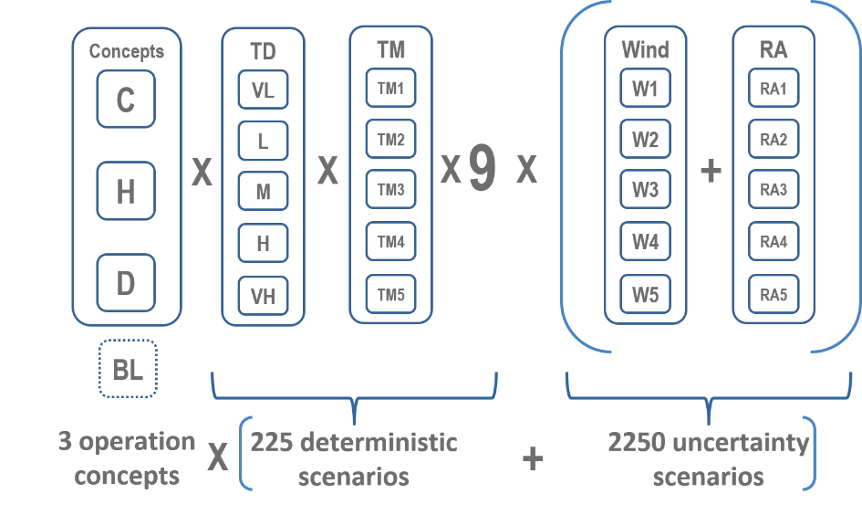

Figure 8. Metropolis 2 experiment matrix.

# Metric definition

The main project research questions are: What is the effect of the deployed separation and flight management strategy: centralised, hybrid and decentralised, and what is the effect of each individual component of the deployed separation and flight management strategy: strategic and tactical on the urban airspace performance? To be able to compare the strategies and components and to answer these research questions, it is necessary to evaluate their performance from different perspectives. Hence, it is first necessary to define the criterions based on which the performance would be evaluated.

These criterions are further called performance indicators. According to the ICAO high-level guidelines (ICAO, 2005) for the ATM system performance evaluation, the performance indicators are classified in the following 11 KPA – Key Performance Areas (in alphabetic order):

* Access and equity
* Capacity
* Cost-effectiveness
* Efficiency
* Environment
* Flexibility
* Global interoperability
* Participation by the ATM community
* Predictability
* Safety
* Security

Some of the areas, such as **Global interoperability** and **Participation by the ATM community**, are not applicable to the UTM system and hence not considered. Furthermore: **Cost-effectiveness**, that take into account balance between the cost of the proposed concept and its service quality, and **Security**, that refers to the protection of drones, people, devices and systems on the ground against threats arising from intentional acts (e.g., terrorism) or unintentional acts (e.g., human error and natural disasters), although very important are not in the scope of the Metropolis 2 project, and hence not considered either.

**Flexibility**, which addresses the ability of the airspace users to modify flight trajectories dynamically and thereby exploiting operational opportunities as they occur, and **Predictability**, which refers to the ability of the UTM system to provide consistent and dependable levels of performance, could not be evaluated in the Metropolis 2 since, on the one hand, the demand for trajectory modification by airspace user is not modelled, and on the other hand, initial flight planning is not available in all concepts. Intuitively, it could be expected that the centralized concept provides good performance in terms of predictability, but that it is less flexible, while the decentralized concept is very flexible, but not predictable. Nevertheless, finding quantitative measures of the flexibility and predictability performance of the centralized and decentralized concepts, and assessing whether the hybrid concept offers the best balance between these two confronted areas is relevant, and should be treated in future work.

Due to specificity of the UTM system, with respect to different types of users and missions, one new performance area is added to the ones defined by ICAO, **Priority**. Priority can be defined as the right of priority access to the UTM resources that certain demands (usually linked to the mission type) could be accorded. When these demands are treated with priority, more beneficial trajectories are possible, but will impact the other lower priority demands. Obviously, it conflicts with Access and equity and the goal would be to see which concept make the best balance.

To conclude, in the Metropolis 2 project, the following performance areas are considered: **Access and equity, Capacity, Efficiency, Environment, Safety, and Priority**. In the subsequent sections, each of these areas will be defined, followed by the proposed indicators that will be used to evaluate concept performance with respect to that area. In the indicator definition, special emphasis will be put on the mathematical formulation and the implementation issues defining the indicator requirements (input data, baseline trajectories, etc.).

## Access and equity

Inspired by the ICAO definition for the ATM system (ICAO, 2005), having good Access and Equity ensures that all users have equal **right of access** to the UTM resources. All mission types/priorities (parcel and food delivery, loitering and emergency missions) and all types of vehicles and their associated characteristics must be accommodated, while **minimising their restriction**.

Hence service **accessibility** can be computed as the number of unfilled demands (deposed flight intentions); and service **equity** can be computed as a measure of share among the users in “a total cost of the solution”, ensuring that there is no significant overall detrimental impact on certain users, even if some individual or groups of users are benefitting.

### AEQ-1: Number of cancelled demands

In a real UTM implementation, regardless of the separating agents (centralized authority, individual users, or a hybrid combination of both) the users will have the ultimate judgment whether flight plans satisfy their demand or not. Hence, based on the filed flight intention, i.e., demand (given by origin, destination vertiport and desired take-off time), if a proposed flight plan is not in accordance with the user requirements (late food delivery, inadequate route for a loitering mission, over-extended route, etc.) such a flight plan won’t be accepted, and a demand will be cancelled by the user. Therefore, the number of cancelled demands I.e., the number of flight intentions that have not been performed represent a fair measure of the UTM service accessibility.

Since user flight plan acceptance is not modelled neither simulated in the Metropolis 2 project, as being out of the scope, the AEQ-1 indicator is post-computed based on an **ideal trajectory,** representing user expectations, and **realized trajectory**[1], coming from simulation, and on the following designed cancellation rules:

* Emergency mission late at destination more than 5 minutes.
* A food delivery mission late at destination more than 10 minutes;
* Loitering mission late at destination more than 20 minutes;

**The ideal trajectory** is computed as the fastest trajectory from origin to destination departing at the requested time as if a user were alone in the system. This ideal trajectory is specific to each concept and it respects all concept airspace rules (flight level usage, street orientation, speed restrictions, etc.) as well as scenario setting e.g., wind, as user have no other option than to respect those rules when calculating his expected trajectory and expected time of arrival.

**The realized trajectory** comes from simulation and is subject to strategic and tactical separation management processes.

Hence for every scenario $s$ and concept $c$, AEQ-1 is calculated as a sum of *characteristic function*[2], **1**, over all flight intentions indicating whether realized arrival time, $t_{sci}$, is greater than ideal expected arrival time, $t_{sci}^{*}$, by more than cancellation delay limit, $τ_{si}$, that is given for every mission type:

$${\text{AEQ-1}}_{sc}= \sum_{i∈I_{s}}{1\left(t_{sci}-t_{sci}^{*} ≥ τ_{si}\right)}$$

where $I_{s}$ is set of flight intentions for a given scenario $s$.

The AEQ-1 can also be expressed as a percentage of cancelled demands, calculated as ratio of the number of cancelled demand and total number of flight intentions in the given scenario, that could be more suitable for some result analysis and comparison. This indicator variant is named **AEQ-1.1 Percentage of cancelled demands**.

### AEQ-2: Number of inoperative trajectories

Even in situations where a UTM user has no specific requirements on maximum mission delay time, that is related to the mission type, there still exists an ultimate mission duration limitation I.e., drone autonomy, that is linked with battery capacity and that should be respected at all costs, since it would make the mission inoperative. If one concept with its strategic and tactical separation management processes yields trajectories whose duration is over-extended (beyond drone autonomy) that is an indicator of poor UTM service accessibility, since those demands could not be served and would be cancelled.

It should be noted that drone autonomy is not considered in the Metropolis 2 simulation environment neither in the planning phase, neither in execution phase, I.e., flight intentions are not cancelled when planned route duration is longer than given drone autonomy, neither drone fall from the sky when battery is empty. Even so, in post-processing, it is possible to compute the number of inoperative flight intentions as number of missions whose total duration is greater than drone's autonomy.

For this purpose, **the realized trajectories** coming from simulation and that are subject to strategic and tactical separation management processes are used and more particularly their total mission durations.

Hence for every scenario $s$ and concept $c$, AEQ-2 is calculated as a sum of *characteristic function*, **1**, over all flight intentions indicating whether realized total trajectory duration, $T_{sci}$, is greater than the specific drone autonomy[3], :

where is set of flight intentions for a given scenario $s$.

Similarly, to AEQ-1.1, we may define **AEQ-2.1 Percentage of inoperative trajectories** as ratio of the number of inoperative trajectories and total number of flight intention in the given scenario.

### AEQ-3: The demand delay dispersion

In statistics, dispersion is a measure of a data spread. Hence, when dispersion is small, data in the given sample are clustered (I.e., squeezed), and when dispersion is large, the data are widely scattered. In Metropolis 2 the dispersion of the demand delay is used as a measure of service equity, where low delay dispersion is an indication of equitable delay distribution among the users. It is a macroscopic indicator since the delay distribution among the users is summarized with a single valued parameter.

The AEQ-3: The demand delay dispersion is computed as a standard deviation[4] of delay of all flight intentions, where delay for each flight intention, $δ_{sci}$, is calculated as a difference between realized arrival time, $t_{sci}$, and ideal expected arrival time, $t_{sci}^{*}$:

$${δ_{sci}=t}_{sci}-t_{sci}^{*}$$

Please note that ideal and realized trajectories are defined in the same way as explained in the AEQ-1; ideal trajectory being computed as the fastest trajectory from origin to destination departing on the requested time as if a user were alone in the system and that considers all concept-specific airspace rules; and realized trajectory coming from simulation, which is subject to strategic and tactical separation management processes.

Hence for every scenario $s$ and concept $c$, the AEQ-3 is computed by following formula:

$${\text{AEQ-3}}_{sc}= \sqrt{\frac{1}{N_{s}}\sum_{i∈I_{s}}{{\left(δ_{sci}-μ_{sc}\right)}^{2}}}$$

Where $N_{s}$ and $I_{s}$ are number and set of flight intentions for a given scenario $s$, and the average value of demand delay for the given scenario $s$ and concept $c$ is calculated as:

$$μ_{sc}= \frac{1}{N_{s}}\sum_{i∈I_{s}}{δ_{sci}}$$

It should be noted that the AEQ-3 unit is the same as the delay unit, therefore it is a time unit e.g., seconds.

### AEQ-4: The worst demand delay

The AEQ-3 is a good indicator of how individual demand delays are spread around mean delay; but it is poor estimate of the outliers I.e., the most penalising or benefiting users. It is exactly what the AEQ-4 indicator, the worst demand delay, is trying to quantify, so representing a complementary measure of the magnitude of the service equity along with AEQ-3.

AEQ-4 is computed as maximal difference between any individual I.e., flight intention delay and the average delay. The flight intention delay, $δ_{sci}$, is calculated as a difference between realized arrival time, $t_{sci}$, and ideal expected arrival time, $t_{sci}^{*}$, and its average value, $μ_{sc}$, as $μ_{sc}= \frac{1}{N_{s}}\sum_{i∈I_{s}}{δ_{sci}}$.

Hence for every scenario $s$ and concept $c$:

$${\text{AEQ-4}}_{sc}= \max_{i∈I_{s}}\left|δ_{sci}-μ_{sc}\right|$$

where $I_{s}$ is set of flight intention for a given scenario $s$.

According to Rawls principle (Rawls, 2005), a "fair" distribution is the one minimising this indicator I.e., minimising the worst demand delay.

It should be noted that the AEQ-4 unit is the same as the delay unit, therefore it is a time unit e.g. seconds.

### AEQ-5: Number of inequitable delayed demands

The AEQ-3 and AEQ-4 indicators represent complementary measures of the magnitude of the service equity. The aim of the AEQ-5 indicator, number of inequitable delayed demands, is to quantify the service equity.

AEQ-5 is computed as the number of flight intentions whose delay is greater than a given threshold from the average delay in an absolute sense. Therefore, the lower the value of the AEQ-5 indicator, the better the system equity.

Recall that the flight intention delay, $δ_{sci}$, is calculated as a difference between realized arrival time, $t_{sci}$, and ideal expected arrival time, $t_{sci}^{*}$, and its average value, $μ_{sc}= \frac{1}{N_{s}}\sum_{i∈I_{s}}{δ_{sci}}$. The equity threshold is a parameter commonly chosen by all UTM system stakeholders, and represents a delay difference that is tolerated as fair, e.g., if no user is penalised/delayed more or less than that given threshold with respect to others, then system is considered equitable. In the Metropolis 2 project, such a parameter will be estimated by numerical tests[5] (an approximate value can be expected around 2-3 minutes).

Hence for every scenario $s$ and concept $c$:

$${\text{AEQ-5}}_{sc}= \sum_{i∈I_{s}}{1\left(\left|δ_{sci}-μ_{sc}\right|>Iq\right)}$$

where $Iq$ is the equity threshold and **1** a *characteristic function* indicating whether flight intention delay is greater or lower than average delay by more than $Iq$.

It should be noted that the number of inequitable delayed demands is not the same as the number of flight intentions delayed more than a given threshold, since the latter is a measure of efficiency rather than equity.

The indicator **AEQ-5.1 Percentage of inequitable delayed demands** can also be defined as a ratio of the number of inequitable delayed demands and total number of flight intentions in the given scenario.

## Capacity

Capacity in the theoretical sense can be defined as the maximum traffic demand that may be served within the UTM system at a given time. A more “service centric” view, currently used in evaluation of the European ATM system performance (EUROCONTROL, 2003), is whether system capacity is in accordance with current needs I.e., if the current demand may be served without imposing restrictions.

Since the main objective in the project is relative comparison of the concepts, we are considering the “service centric” view. Hence degradation of the system efficiency or safety indicators is, beside others, the result of a **lack of the system capacity** and can be used as its proxy. The difficulty is that the proposed concepts have on the one hand a different policy for the demand regulations (rerouting, delayed departures...) and different airspace structure (unidirectional/bidirectional streets, predefined flight levels, etc.); and on the other hand different separation management components, hence the resulting efficiency and safety metrics can be biased by those differences.

It should be noted that insights about **theoretical system capacity** can be revealed by comparing the degradation of proposed “service centric” capacity indicators with respect to demand. Hence, theoretical capacity can be defined as a point where system performance is degrading exponentially with increase of the demand, an approach proposed in (Delahaye, et al., 2014). This aspect will be considered in the result analysis.

Furthermore, another category of indicators dealing with the aspect of **capacity resilience** is proposed. Resilience is the ability to withstand and recover from planned and unplanned events and conditions which cause a loss of nominal capacity (SESAR Joint Undertaking , 2016).

### CAP-1: Average demand delay

Although a flight intention delay represents direct measure of the system efficiency, it can also be used as a proxy for the lack of the system capacity as previously explained. The more flights are delayed, the bigger the capacity problem is. Hence, it can be used for the relative comparison of the concepts. Obviously, a situation when no demand suffered from delay only confirms that system capacity commensurate the demand but doesn’t provide its actual measure.

The CAP-1: Average demand delay is computed as the arithmetic mean of the delays of all flight intentions, where the delay for each flight intention, $δ_{sci}$, is calculated as the difference between realized arrival time, $t_{sci}$, and ideal expected arrival time, $t_{sci}^{*}$:

$${\text{CAP-1}}_{sc}=\frac{1}{N_{s}}\sum_{i∈I_{s}}{δ_{sci}}$$

where $N_{s}$ and $I_{s}$ are the number and set of flight intentions for a given scenario $s$, and ${δ_{sci}=t}_{sci}-t_{sci}^{*}$, is the flight intention delay.

Please note that ideal and realized trajectories are defined in the same way as explained in the AEQ-1; ideal trajectory being computed as the fastest trajectory from origin to destination departing at the requested time as if a user were alone in the system, considering all concept-specific airspace rules; and realized trajectory coming from the simulation, which is subject to strategic and tactical separation management processes.

The CAP-1 unit is the same as the delay unit, therefore it is a time unit e.g., seconds.

### CAP-2: Average number of intrusions

Similar to CAP-1, the number of intrusions, a safety indicator, can be used as a proxy for system capacity for relative comparison of different concepts.

The CAP-2: Average number of intrusions is computed as a ratio of the total number of intrusions, the number of situations in which the distance between two aircraft is smaller than separation norm of 32 metres horizontally and 25 feet vertically (see SAF-2 indicator) and the number of flight intentions:

$${\text{CAP-2}}_{sc}=\frac{1}{N_{s}}{\text{SAF-2}}_{sc}$$

where ${\text{SAF-2}}_{sc}$ is the total number of intrusions for a given concept $c$ and scenario $s$ and is provided from the simulation, and $N_{s}$ is the number of flight intentions for a given scenario $s$.

### CAP-3: Additional demand delay

Capacity resilience in the Metropolis 2 project is measured by comparing nominal and uncertainty scenarios with rogue aircrafts (aircrafts that do not obey any controls, nor follow the airspace rules of the concept). Since disruptive events last through-out the whole simulation duration, it is not possible to measure recovery from these events, but their magnitude can be observed.

CAP-3: additional demand delay is calculated as the increase of the CAP-1 average demand delay due to the introduction of rogue aircraft. Clearly a concept that does not suffer from additional degradation of the CAP-1 indicator when introducing rogue aircraft can be considered resilient.

Hence for a given concept $c$ and a given nominal scenario $s$ (scenarios without uncertainty), CAP-3 is calculated by following formula:

$${\text{CAP-3}}_{sc}={\text{CAP-1}}_{s^{r}c}-{\text{CAP-1}}_{sc}$$

where $s^{r}$ is a corresponding scenario with rogue aircraft to the scenario $s$.

### CAP-4: Additional number of intrusions

Similarly, capacity resilience can be measured using the degradation of the intrusions safety indicator when rogue aircraft are introduced. CAP-4: the additional number of intrusions is computed as an increase of the CAP-2 average number of intrusions with the introduction of rogue aircraft.

Hence for a given concept $c$ and a given nominal scenario $s$ (scenarios without uncertainty), CAP-4 is calculated:

$${\text{CAP-4}}_{sc}={\text{CAP-2}}_{s^{r}c}-{\text{CAP-2}}_{sc}$$

where $s^{r}$ is a corresponding scenario with rogue aircraft to the scenario $s$.

## Efficiency

Within the Metropolis2 project we are interested in distance and time flown, and energy efficiency, all included in the performance/operation efficiency category, of each concept and we shall not consider the complexity or the financial and human-hour cost of the proposed systems. While the reason behind using energy and time efficiency metrics to evaluate the performance efficiency of the UTM concept, the use of distance metrics might seem a bit unnecessary, we need to consider that optimizing the distance of the aircraft’s route has a positive impact on the time and energy efficiency as well as to the overall traffic.

So, even though the distance efficiency metrics should not be used as an evaluation indicator of the overall system performance, they can contribute to the detection of drawbacks in the design or implementation of the system. To increase the efficiency of a system we must increase the route distance-related metrics while decreasing the delay and work done on related metrics.

### EFF-1: Horizontal distance route efficiency

This metric represents the extension of the horizontal route distance compared to the ideal one that is a computed by dividing the length of the ideal horizontal route by the length of the actual horizontal route. The actual horizontal route is defined as the 2D projection in the horizontal plane of the route conducted by the aircraft, measured in meters. The ideal horizontal route is the Euclidean distance connecting the origin point to the destination point of the aircraft, measured in meters. The ideal route as defined here is in most cases not feasible, especially for the constrained airspace where the aircraft are obligated to follow the street network, and the referred metric will never take the value of 1 or 100%. It simply represents the lower bound of horizontal distance, that is ideal from optimization point of view, and that provide the same reference for all concepts and allows concept comparison. If one is interested in pure evaluation of the concept performance with respect to efficiency and prefer on using the shortest feasible path, then it would be obligated to set a more realistic lower bound. But while that is achievable for the constrained airspace by modifying the street network to be bi-directional and using a graph search algorithm such as Dijkstra’s algorithm (Sedov & Polischuk, 2018), the computation of the shortest path for the open and mixed airspace is a much more complex task due to the lack of structure in the open airspace. The equation for calculating this metric per aircraft is presented below.

$$E_{hdr}=\frac{{length}_{ideal_horizontal_route}}{{lentgh}_{actual_horizontal_route}}=\frac{horizontal_euclidean_distance(origin_point,destination_point)}{{lentgh}_{actual_horizontal_route}}$$

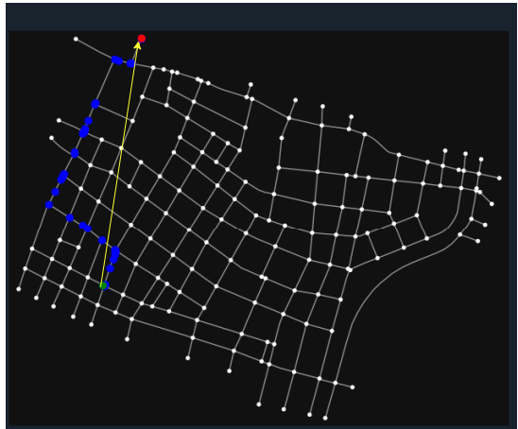

Figure 9. Actual and ideal horizontal path. The origin point is coloured green, the destination point is red.   
The actual route is shown blue, while the ideal route is the yellow arrow.

### EFF-2: Vertical distance route efficiency

This metric [13] is a percentage computed by dividing the vertical distance conducted in the ideal route by the vertical distance conducted in the actual route. In the ideal case, the vertical distance should only include the ascending from the take-off point to the lowest altitude of flying, and the descending from that altitude to the landing point, measured in meters. The actual vertical distance is the sum of all the ascending or descending distances executed by the aircraft while conducting its route, measured in meters. The actual vertical distance can be graphed as the 2D projection in the vertical plane of the route conducted by the aircraft. The equation for calculating this metric per aircraft is presented below.

$$E_{vdr}=\frac{{length}_{ideal_vertical_route}}{{lentgh}_{actual_vertical_route}}=\frac{2×{height}_{lowest_layer}}{\sum{ascending_distances}+\sum{descending_distances}}$$

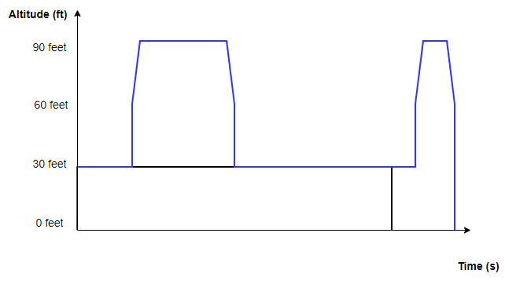

Figure 10. Graph of the altitude for the ideal vertical route (in black) and the actual vertical route (in blue).

### EFF-3: Ascending route efficiency

The Ascending route efficiency metric is a percentage computed by dividing the ideal ascending distance by the ascending distance conducted. The ideal ascending distance includes only the distance from the take-off to the lowest altitude of flying. The actual ascending distance is the sum of all the vertical distances conducted by the aircraft while ascending. Both the actual and ideal ascending distances are measured in meters. This metric separates the ascending distance from the overall vertical distance conducted since ascending has the most important impact on the energy efficiency of the route. The equation for calculating this metric per aircraft is presented below.

$$E_{ar}=\frac{{length}_{ideal_ascending_distance}}{{lentgh}_{actual_ascending_distance}}=\frac{{height}_{lowest_layer}}{\sum{ascending_distances}}$$

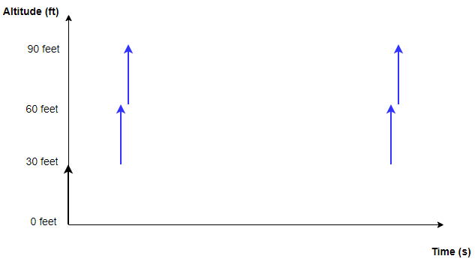

Figure 11. Graph of the ascends for the ideal vertical route (in black) and the actual vertical route (in blue).

### EFF-4: 3D distance route efficiency

The 3D distance route efficiency metric is a percentage computed by dividing the ideal 3D distance of the route by the actual 3D distance of the route. This metric is a combination of the horizontal distance route efficiency metric and the vertical distance route efficiency metric. The equation for calculating this metric per aircraft is presented below.

$$E_{3Ddr}=\frac{{length}_{ideal_3d_route}}{{lentgh}_{actual_3d_route}}=\frac{horizontal_euclidean_distance(origin_point,destination_point)+2×{height}_{lowest_layer}}{{lentgh}_{actual_3d_route}}$$

### EFF-5: Route duration efficiency

The route duration efficiency metric is a percentage computed by dividing the time duration of the ideal route by the time duration of the actual route. The time duration of the ideal route is computed by dividing the length of the horizontal ideal route by the maximum speed of the aircraft. The time duration of the actual route is measured from the time that the aircraft left its take-off vertiport until it reaches its destination vertiport, in that way the route duration efficiency is independent of the departure, departure sequence, and arrival sequence delay metrics which will be presented later in this section, and is extracted from the data created by the simulation. In both cases, the time duration is measured in seconds. The equation for calculating this metric per aircraft is presented below.

$$E_{rd}=\frac{{time_{duration}}_{ideal_{route}}}{{time_{duration}}_{actual_{route}}}=\frac{\frac{horizontal_euclidean_distance(origin_point,destination_point)}{max⁡_aircraft_speed}}{{time_of_vertiport_arrival}_{actual}-{time_of_vertiport_departure}_{actual}}$$

### EFF-6: Departure delay

This is a time metric (Xue, 2020) equal to the time duration from the planned departure time until the actual departure time of the aircraft. The metric is measured in seconds. In the ideal case, the aircraft is departing at the planned time and the metric is equal to 0 seconds. Departure delay shows how long the aircraft has to wait until it can start its flight and it is caused by high aircraft capacity in the airspace, departure sequencing, or flight regulations. The equation for calculating this metric per aircraft is presented below.

$$D_{d}={time}_{actual_departure}-{time}_{planned_departure}$$

### EFF-7: Departure sequence delay

This is a time metric (Xue, 2020) equal to the time duration from the time that the aircraft starts its flight to the time that the aircraft takes off from the origin point. This metric is measured in seconds. In the ideal case, this metric is equal to 0 seconds. The departure sequence delay metric shows how long the aircraft will wait and land at the take-off point until it can be able to take off. It is caused by the aircrafts’ congestion over the vertiport since the aircraft needs to keep the required separation distance during the take-off process. The equation for calculating this metric per aircraft is presented below.

$$D_{ds}={time}_{take_off}-{time}_{actual_departure}$$

### EFF-8: Arrival sequence delay

This is a time metric equal to the time duration from the time that the aircraft arrived at the destination vertiport to the time that the aircraft landed at the destination point. This metric is measured in seconds. In the ideal case, this metric is equal to 0 seconds. The arrival sequence delay metric shows how long the aircraft will wait and hover over the landing point until it can be able to land. It is caused by aircraft's congestion over the vertiport since the aircraft needs to keep the required separation distance while landing. The equation for calculating this metric per aircraft is presented below.

$$D_{as}={time}_{reached_laning_vertiport}-{time}_{landing}$$

## Environment

The UTM system affects the environment in the numerous ways (see Figure 12). These impacts can be split in two categories: third-party risk and pollution. The first category, third-party risk is considered out of the scope in the Metropolis 2 project. Pollution on other hand can be considered from emissions, noise, and light pollution. Light pollution is not considered due to lack of data, and the fact that its impact on the society is not yet clear.

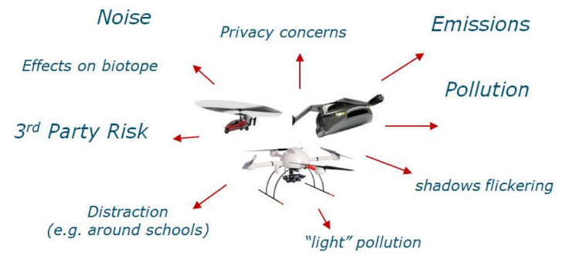

Figure 12. Environmental concerns in the UTM (Delahaye, et al., 2014)

Based on increasing concerns regarding the effects of emissions on the environment and especially the urban environment (diesel vehicles being prohibited in core city centres of world metropoles) it is assumed that all drones in the UTM will be electrically powered. However, despite being electrically powered, efficient energy use is still an important concern for the concept comparison and can be measured through **energy efficiency** metrics.

**Noise pollution** is generally defined as regular exposure to elevated sound levels that may lead to adverse effects in humans or other living organisms.

### ENV-1: Work done

The ENV-1: work done corresponds to the total energy required to perform all flight intentions and it is used as indicator of the energy efficiency and environmental impact. Because there is no data available on energy use-related aspects such as motor and battery efficiency, work done is used as an indicator of actual energy used.

For every flight, work done is computed by integrating the thrust (force) over the route displacement. It is measured in Joules (J) and it is provided directly from the Bluesky simulator numerically computing the integral by summing over all simulation time steps the product of the thrust and travelled distance, as in following equation (Delahaye, et al., 2014):

$$WD=\sum_{t=t_{dep}}^{t_{arr}}{Th(t)∙\sqrt{{υ_{h}(t)}^{2}+{υ_{v}(t)}^{2}}∙∆t}$$

where $Th(t)$ represents the thrust for the given flight at the time $t$, $υ_{h}(t)$ and $υ_{v}(t)$ are respectively the horizontal and vertical speed of that flight at the time $t$, and $t_{dep}$ and $t_{arr}$ are respectively departure and arrival time of that flight.

ENV-1: work done for every concept $c$ and scenario $s$ is then simply calculated by summing individual work done of all flight intentions in the scenario:

$${\text{ENV-1}}_{sc}=\sum_{i∈I_{s}}{{WD}_{sci}}$$

where $I_{s}$ is the set of flight intentions for a given scenario $s$, and ${WD}_{sci}$ is the individual flight intention $i$ work done for the given concept $c$ and scenario $s$.

### ENV-2: Weighted average altitude

Due to the unavailability of an accurate noise emission model of future drones that will be used in the UTM, several simplified indicators of noise emissions are proposed in Metropolis 2.

ENV-2: weighted average altitude measures the noise effect on the people on the ground, such as pedestrians, considering them as the most affected population in the urban environment. It is hypothesised that drones flying lower and for a long period of time affect more people on the ground. The indicator is determined by integrating the flight altitude over the route displacement and can be computed numerically during the simulation or in the posttreatment using the following equation:

$${\text{ENV-2}}_{sc}={\sum_{i∈I_{s}}{\sum_{d∈D_{sci}}{{FL}_{scd}∙l_{scd}}}}/{\sum_{i∈I_{s}}{\sum_{d∈D_{sci}}{l_{scd}}}}$$

where $I_{s}$ is the set of flight intentions for a given scenario $s$, $D_{sci}$ is the set of the flight segments of the flight intention $i$ in scenario $s$ for the concept $c$, and ${FL}_{scd}$ and $l_{scd}$ are the flight altitude and the length of the flight segment of the flight segment $d$ (of the flight intention $i$) in scenario $s$ for the concept $c$. It should be noted that vertical flight segments are considered with an average altitude.

Although ENV-2 is computed as the weighted average of all flight intentions, let’s illustrate from the perspective of a single flight (see Figure 13). In this illustrative example vertical movements are neglected for sake of simplicity. Let’s consider a drone trajectory flying its first 100 meters at an altitude of 50 meters, the next 1000 meters at 150 meters of altitude, and finally the last 400 meters at 100 meters of altitude. By the hypothesis of the ENV-2 indicator it produces an equivalent noise as a drone flying all 1500 meters at the altitude of 130 meters, based on the following calculation:

$$50*100 + 150*1000 + 100*400/ 1500 = 130$$

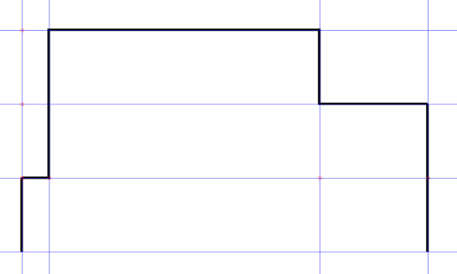

distance along the trajectory [m]

0

100

1100

1500

altitude [m]

0

50

100

150

Figure 13. Vertical profile example

### ENV-3: Equivalent Noise Level

In acoustic, inverse square law states that sound intensity reduces with the square of the distance as, meaning that doubling the distance drops the sound intensity to a quarter (see Figure 14). More commonly it is referred with decibels, where doubling the distance drops the sound level by 6dB, as in following equation:



where represent the sound level difference, is reference sound intensity of $1{pW}/m$, and is relative distance.

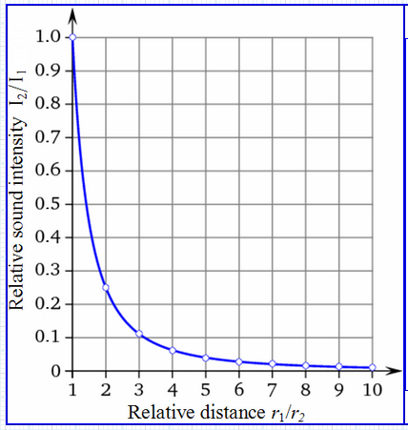

Figure 14. Sound intensity reduction with distance

The macroscopic indicator ENV-2, however, neglect this dependence due to difficulty/impossibility of the sound aggregation over the surface to get a single indicator. ENV-3: Equivalent noise level try to account better for invers square law of acoustic by computing the sound intensity for a given point at the surface of the city area at a given time, and then aggregating it over a time into single equivalent noise level for that point.

For a given concept $c$, scenario $s$, point $p$ in the city area at a given time $t$, total sound intensity, $I_{scpt}$, from all sources i.e. flying vehicles, could be calculated by following formula:



where $I_{s}$ is the set of flight intentions for a given scenario $s$, $r_{cipt}$ is relative distance of the sound source i.e., flying vehicle $i$ of scenario $s$ in the concept $c$ at time $t$ from a point $p$ that is calculated as a ratio between $R_{cipt}$, the absolute distance of flying vehicle $i$ of scenario $s$ in the concept $c$ at time $t$ from a point $p$ and reference distance, $R_{ref}$. This means that intensity of all sound sources would be scaled as they were all at this reference distance. For example, the lowest available flight level could be selected as the reference distance. Also remark that there is no intensity at the source in the formula. Since we don’t have accurate noise models for the future vehicles, this parameter is not known. However, the result would be simply scaled (multiplied) with the intensity if known.

The equivalent noise level, $L_{scp}$, for a given concept $c$, scenario $s$, and a point $p$ in the city area could be then computed by aggregating $I_{scpt}$ over time:



The integral could be numerical approximate if time is discretized, as a simple weighted time average of the time-period sound intensities $I_{scpt}$. The indicator unit is dB.

Similarly, the city surface would be discretized as well. This way for every concept and scenario, a matrix (of two dimensions for latitude and longitude) of equivalent noise level, $L_{scp}$, for all surface points in the city would be computed. These values could be used for the statistical comparison of the concepts using average, maximum, IQR of equivalent noise level produce by the concept. Using different matrix norm, as a measure of the distance between the matrices, the $L_{scp}$ could be aggregated into a single indicator.

The indicator, however, consider numerous hypothesis. In the real world, the inverse square law is always an idealization because it assumes exactly equal sound intensity propagation in all directions, neglecting air temperature, humidity, and any sound reflection and barriers in the sound field. We also assume that all noise sources have equal power, that further doesn’t depend on drone type, neither engine operation mode (climbing, cruising…). Finally, considering that buildings would represent barriers for the spherical noise wave propagation, it is considered that noise sources only effect the surface that is located vertical below the trajectories i.e., sound intensity is propagated only vertically.

### ENV-4: Altitude dispersion

The second noise indicator, ENV-4: Altitude dispersion, is based on the hypothesis that dispersing the noise events would reduce the noise picks, and hence reduce the affected population with the noise greater than a given limit.

The ENV-4 indicator is calculated as the difference between maximum and minimum length flown at a flight level divided by average length flown at that level, as follows:

$${\text{ENV-4}}_{sc}=\frac{\max_{a∈A}{l_{a}}-\min_{a∈A}{l_{a}}}{1/{\left|A\right|}\sum_{a∈A}{l_{a}}}$$

where $A$ is the set of flight levels and $\left|A\right|$ their number, and $l_{a}$ is the length flown (spent) in total by all flight intentions on flight level $a$. Since the predefined flight levels are not part of the common airspace structure, and concepts may define their own flight levels or not define them at all, to compute this indicator a unique altitude discretization would be proposed.

The ENV-4 indicator is dimension-less, and in the perfect altitude distribution, from a noise perspective, when every flight level is equally used (i.e., flown length of every flight level is the same), the value of the ENV-3 indicator would be 0.

Finally, it should be noted that this indicator neglects noise source dispersion in time, even though this is an important aspect of noise aggregation.

## Safety

The following section presents the metrics considered to quantify the level of safety achieved within each simulation run. In the Metropolis 2 project, the level of safety will be represented by a collection of indicators emphasizing the safe separation of aircraft, as well as their ability to respect geofenced areas.

### SAF-1: Number of conflicts

Within the Metropolis 2 project, a conflict is counted when the current states of two aircraft would result in a loss of separation within a look-ahead time of 10 seconds. Due to the street layout of Vienna, and the constraint that aircraft must follow streets in the city centre, state-based conflict detection will occasionally detect false conflicts from aircraft that have non-intersecting paths. However, it is still a meaningful metric, as false conflicts can be detected and accounted for.

Figure 15. A conflict is a predicted loss of separation within the look-ahead time.

### SAF-2: Number of intrusions

An intrusion is defined as the situation in which the distance between two aircraft is smaller than 32 metres. This is an unsafe situation due to the positioning system accuracy, as collision avoidance cannot be guaranteed.

Figure 16. An intrusion occurs when the distance between two aircraft is smaller than the separation margin (protection zone radius Rpz).

### SAF-3: Intrusion prevention rate

The intrusion prevention rate is a value that shows what proportion of conflicts did not result in a loss of separation. This is found by using the equation below.

$$R_{prevented}= \frac{Number of resolved conflicts}{Number of conflicts}$$

If represented as a percentage, 100% means that all conflicts have been resolved, and a lower percentage means that there were conflicts that resulted in a loss of separation.

### SAF-4: Minimum separation during intrusions

By recording and analysing the minimum separation during intrusions, the severity of losses of separation can be evaluated to determine how great the collision probably was. This permits further comparison between concepts from the point of view of safety, as the strategies in case of a loss of separation can be evaluated.

### SAF-5: Time spent in state of intrusion

The time spent in a state of intrusion is also a metric that can be used to evaluate the intrusion resolving strategy of the concepts. A low value contributes towards a higher level of safety.

### SAF-6: Number of geofence/building area violations

The last key performance indicator for safety used within the Metropolis 2 project is the number of geofence or building violations. While the street network is used within the project to specifically avoid collisions with buildings, this metric can reveal issues with the tactical separation algorithms as well as the path planning and strategic separation algorithms.

## Priority

Within the Metropolis 2 project, the effect of the prioritisation of missions on airspace performance will be considered. These effects can be inferred from other indicators, such as the safety and efficiency metrics, but also by comparing priority-specific key performance indicators between the concepts. There are three mission priority levels (priority levels 1,2, and 3), and an emergency vehicle priority level (priority level 4).

### PRI-1: Weighted mission duration

By assigning weights to the mission time in function of mission priority, the overall performance of concept operations can be determined and compared. The following equation below will be used to calculate this, by multiplying the weight for each priority level with the sum of mission times for all missions in each priority category:

$$T_{tot,w}= w_{1}\sum{T_{prio=1}+w_{2}\sum{T_{prio=2}}}+ w_{3}\sum{T_{prio=3}+w_{4}\sum{T_{prio=4}}}$$

### PRI-2: Weighted mission track length

This performance indicator is similar to **PRI-1**, but covers total distance travelled. Thus, it will be calculated using the equation below.

$$D_{tot,w}= w_{1}\sum{D_{prio=1}+w_{2}\sum{D_{prio=2}}}+ w_{3}\sum{D_{prio=3}+w_{4}\sum{D_{prio=4}}}$$

### PRI-3: Average mission duration per priority level

This performance indicator will show how the priority levels influenced the average mission duration within the traffic scenarios, and will outline the emphasis (or lack thereof) on certain priority categories. This metric will be computed using the equation below, by dividing the total mission time for all drones within a certain priority level category by the number of aircraft in that category.

$$T_{prio,avg}= \frac{\sum{T_{prio}}}{N_{prio}}$$

### PRI-4: Average mission track length per priority level

This performance indicator is similar to **PRI-3**, but focuses on the track length. It will be calculated using the equation below.

$$D_{prio,avg}= \frac{\sum{D_{prio}}}{N_{prio}}$$

### PRI-5: Total delay per priority level

The last key performance indicator used to evaluate the use of priority within urban airspace is the delay per priority level. In this case, delay has two components:

* Pre-departure delay due to strategic deconfliction or vertiport capacity considerations;
* Mission time delay, determined by comparing the mission time between the concept scenarios and the baseline scenario.

Thus, the total delay will be calculated using the equation below.

$$T_{delay,total}= \sum{\left(T_{dep, real}-T_{dep,pref}\right)+ \sum{(T_{mission,real}-T_{mission,baseline})}}$$

## Summary of all proposed indicators

This section contains a table summarising all proposed indicators with special intention on indicator computation (intended for platform developers) and data source (intended for BlueSky development in WP5).

Table 3. Summary of the indicator proposed in the Metropolis 2

|  |  |  |
| --- | --- | --- |
| Indicator | Unit | Description |
| Access and equity | | |
| **AEQ-1: Number of cancelled demands** | - | Number of situations when realized arrival time of a given flight intention is greater than ideal expected arrival time by more or equal than some given cancellation delay limit that depends on mission type.  Ideal expected arrival time is computed as arrival time of the fastest trajectory from origin to destination departing at the requested time as if a user were alone in the system, respecting all concept airspace rules. Realized arrival time comes directly from the simulations. |
| **AEQ-1.1 Percentage of cancelled demands** | % | Calculated as the ratio of AEQ-1 and the total number of flight intentions in the given scenario. |
| **AEQ-2: Number of inoperative trajectories** | - | Number of situations when realized total mission duration is greater than specific drone autonomy.  Realized trajectories and hence realized total mission duration comes directly from a simulation. |
| **AEQ-2.1: Percentage of inoperative trajectories** | % | Calculated as the ratio of AEQ-2 and the total number of flight intentions in the given scenario. |
| **AEQ-3: The demand delay dispersion** | sec | Measured as standard deviation of delay of all flight intentions, where delay for each flight intention is calculated as a difference between realized arrival time and ideal expected arrival time.  Ideal expected arrival time is computed as arrival time of the fastest trajectory from origin to destination departing at the requested time as if a user were alone in the system, respecting all concept airspace rules. Realized arrival time comes directly from the simulations. |
| **AEQ-4: The worst demand delay** | sec | Computed as the maximal difference between any individual flight intention delay and the average delay; where delay for each flight intention is calculated as the difference between realized arrival time and ideal expected arrival time. |
| **AEQ-5: Number of inequitable delayed demands** | - | Number of flight intentions whose delay is greater than a given threshold from the average delay in absolute sense, where delay for each flight intention is calculated as the difference between realized arrival time and ideal expected arrival time. |
| **AEQ-5-1: Percentage of inequitable delayed demands** | % | Calculated as the ratio of AEQ-5 and the total number of flight intentions in the given scenario. |
| Capacity | | |
| **CAP-1: Average demand delay** | sec | Measured as an arithmetic mean of delay of all flight intentions, where delay for each flight intention is calculated as the difference between realized arrival time and ideal expected arrival time.  Ideal expected arrival time is computed as arrival time of the fastest trajectory from origin to destination departing at the requested time as if a user were alone in the system, respecting all concept airspace rules. Realized arrival time comes directly from the simulation. |
| **CAP-2: Average number of intrusions** | - | Number of intrusions per flight intention I.e., a ration between total number of intrusions (SAF-2 indicator) and number of flight intentions.  Intrusions are situations in which the distance between two aircraft is smaller than separation norm of 32 metres horizontally and 25 feet vertically, and is directly computed during the simulation. |
| **CAP-3: Additional demand delay** | sec | Calculated as an increase of the CAP-1 indicator with the introduction of rogue aircraft. |
| **CAP-4: Additional number of intrusions** | - | Calculated as an increase of the CAP-2 indicator with the introduction of rogue aircraft. |
| Efficiency | | |
| **EFF-1: Horizontal distance route efficiency** | % | Ratio representing the length of the ideal horizontal route to the actual horizontal route. |
| **EFF-2: Vertical distance route efficiency** | % | Ratio representing the length of the ideal vertical route to the actual vertical route. |
| **EFF-3: Ascending route efficiency** | % | Ratio representing the length of the ascending distance in the ideal route to the length of the ascending distance of the actual route. |
| **EFF-4: 3D distance route efficiency** | % | Ratio representing the 3D length of the ideal route to the 3D length of the actual route. |
| **EFF-5: Route duration efficiency** | % | Ratio representing the time duration of the ideal route to the time duration of the actual route. |
| **EFF-6: Departure delay** | sec | Time duration from the planned departure time until the actual departure time of the aircraft. |
| **EFF-7: Departure sequence delay** | sec | Time duration from the time that the aircraft starts its flight to the time that the aircraft takes off from the origin point. |
| **EFF-8: Arrival sequence delay** | sec | Time duration from the time that the aircraft arrived at the destination vertiport to the time that the aircraft landed at the destination point. |
| Environment | | |
| **ENV-1: Work done** | Joules | Representing total energy needed to perform all flight intentions, computed by integrating the thrust (force) over the route displacement. The indicator is directly computed in the Bluesky simulator. |
| **ENV-2: Weighted average altitude** | meters | Average flight level weighed by the length flown at each flight level. |
| **ENV-3: Equivalent Noise Level** | dB | Represent total sound exposure at the given point on city area surface. It is computed by aggregating the total sound intensity (of all sound sources) at that given point over the time. |
| **ENV-4: Altitude dispersion** | - | The ratio between the difference of maximum and minimum length flown at a flight level and average length flown at level. |
| Safety | | |
| **SAF-1: Number of conflicts** | - | Number of aircraft pairs that will experience a loss of separation within the look-ahead time. |
| **SAF-2: Number of intrusions** | - | Number of aircraft pairs that experience loss of separation |
| **SAF-3: Intrusion prevention rate** | - | Ratio representing the proportion of conflicts that did not result in a loss of separation. |
| **SAF-4: Minimum separation** | - | The minimum separation between aircraft during conflicts. |
| **SAF-5: Time spent in LOS** | - | Total time spent in a state of intrusion. |
| **SAF-6: Geofence violations** | - | The number of geofence/building area violations. |
| Priority | | |
| **PRI-1: Weighted mission duration** | - | Total duration of missions weighted in function of priority level. |
| **PRI-2: Weighted mission track length** | - | Total distance travelled weighted in function of priority level. |
| **PRI-3: Average mission duration per priority level** | - | The average mission duration for each priority level per aircraft. |
| **PRI-4: Average mission track length per priority level** | - | The average distance travelled for each priority level per aircraft. |
| **PRI-5: Total delay per priority level** | - | The total delay experienced by aircraft in a certain priority category relative to ideal conditions. |

# References

Barrado, C., Boyero, M., Brucculeri, L., Ferrara, G., Hately, A., Hullah, P., . . . Volkert, A. (2020). U-Space Concept of Operations: A Key Enabler for Opening Airspace to Emerging Low-Altitude Operations. *Aerospace, 7*(3).

Barrington-Leigh, C., & Millard-Ball, A. (2017). The world's user-generated road map is more than 80% complete. *PLOS ONE*.

Boeing, G. (2017 ). OSMnx: New methods for acquiring, constructing, analyzing, and visualizing complex street networks . *Computers, Environment and Urban Systems* , 126-139.

Boeing, G. (2019). Urban spatial order: Street network orientation, configuration, and entropy. *Applied Network Science, 4*(1).

Bulusu, V., Polishchuk, V., Sengupta, R., & Sedov, L. (2017). Capacity Estimation for Low Altitude Airspace. *de 17th AIAA Aviation Technology, Integration, and Operations Conference.* Denver.

City of Vienna. (2019). *Population and surface of Vienna's municipal districts 2019*. Retrieved 2021, from https://www.wien.gv.at/english/administration/statistics/population-district.html

City of Vienna. (2021). *Baukörpermodell (LOD0.4) Grunddaten aus der Flächen-MZK Vektordaten Wien* . Retrieved 05 2021, from https://www.data.gv.at/katalog/dataset/76c2e577-268f-4a93-bccd-7d5b43b14efd

Delahaye, D., Vidosavljevic, A., Sunil, E., Hoekstra, J., Ellerbroek, J., & Aalmoes, R. (2014). *METROPOLIS D3.2 Development & Metrics Definition.*

Doole, M., Ellerbroek, J., & Hoekstra, J. (2020). Estimation of traffic density from drone-based delivery in very low level urban airspace. *Journal of Air Transport Management, 88*.

Doole, M., Ellerbroek, J., Knoop, V. L., & Hoekstra, J. M. (2021). Constrained Urban Airspace Design for Large-Scale Drone-Based Delivery Traffic. *Aerospace, 8*(2).

EUROCONTROL. (2003). *ATM Strategy for the Years 2000+ (Volume 1.* Brussels.

ICAO. (2005). *Doc. 9854 - Global Air Traffic Management Operational concept.* Montreal, Canada.

OpenStreetMap. (2009). *Hall of Fame/Streets Complete*. Retrieved 11 2021, from https://wiki.openstreetmap.org/wiki/Hall_of_Fame/Streets_complete

Pitney Bowes. (2020). *Pitney Bowes 2.0 Shaping our next century of growth.* Retrieved 2021, from https://www.pitneybowes.com/us/our-company/annual-report.html

Rawls, J. (2005). *A theory of justice.* Belknap Press of Harvard University Press.

Sedov, L., & Polischuk, V. (2018). Centralized and DIstributed UTM in Layered Airspace. *de 8th International Conference on Research in Air Trasnportation (ICRAT).* Barcelona.

SESAR Joint Undertaking . (2016). *Project B04.01 - Performance Framework for SESAR 2020 Transition.* Brussels.

Statistik Austria. (n.d.). *STATatlas*. Retrieved 2021, from https://www.statistik.at/atlas/

Xue, M. (2020). Urban Air Mobility Conflict Resolution:Centralized or Decentralized? *de AIAA AVIATION 2020 FORUM.* VIRTUAL EVENT.

|  |  |  |
| --- | --- | --- |
|  |  |  |
|  |  |  |
|  |  |  |
|  |  |  |
|  |  |  |
|  |  |  |
|  |  |  |
|  |  |  |

1. It should be noted that here a realized trajectory is used as a best possible plan, since no all concepts contains the reliable flight planning.
2. In mathematics, the characteristic function returns value 1 when a given condition is satisfied, and zero otherwise.
3. for every scenario and every flight intention, drone type is given in the flight intention file and hence drone autonomy is uniquely defined.
4. Standard deviation is one of the most common measures of the dispersion. It is used since it has the same units as the quantity being measured.
5. It should be noted that the equity threshold parameter has mainly a psychological character and that physically this value might differ with total duration of the flight intention e.g., delaying by 2 minutes one flight with total duration of 5 minutes is not the same as delaying other that lasts 15 minutes.